Resume

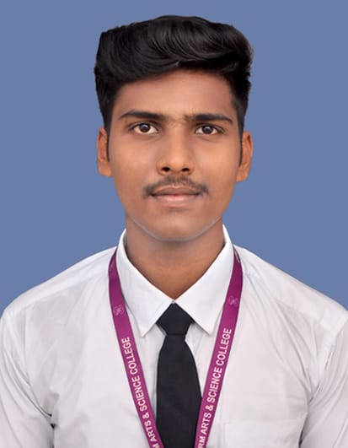

MOHAN RAJ M

+91 7358568314

[ajithmohan8274@gmail.com](mailto:ajithmohan8274@gmail.com)

A meticulous and organized individual seeking an Entry-level position in the field of Management. Specialized in administrative support and committed to delivering high quality results and an Inventive problem solver with an ability to perform different tasks with good interpersonal skills.

|  |
| --- |
| Education |
| * Completed **Bachelor of Science in Hotel Management** – **SRM Institute of Hotel Management** in the year 2022 * H.S.C (state board) – **Sri Sankara Vidhya Kendra matric higher secondary school - With 57%** in the year2019. * SSLC (state board) – **Shebha matric higher secondary school - With 76%** in the year 2017. |

|  |
| --- |
| **Technical Skill** |
| **ORACLE** |
| **SQL** |
| **PL/SQL Analysis Design & Implementation** |

|  |
| --- |
| **Certification** |
| **Completed ORACLE & PL/SQL Course in Greens Technology during OCT 2022 – January 2023.** |

|  |
| --- |
| Internship Experience |
| **ITC GRAND CHOLA** –Worked as an Intern and managed a team of 5 for a formal Banquet. |
| **THE RESIDENCY HOTEL –** Formal and InformalBanquet. |
| **INTER CONTINENTAL –** Worked as an Intern onFormal Banquet Sector. |
| **HILTON –** Worked as an Intern on Hospitality and People Management Sectors for 3 months. |
| **OVENSTORYPIZZA –** Worked as an Intern on Product Management Sector for 6 months. |

|  |
| --- |
| Personal Skills |
| * **Good Listening Skills** * **Team Management** * **Good Leadership Skills** * **Quick Learner** |

|  |
| --- |
| Language Skill |
| **Tamil** |
| **English** |

|  |
| --- |
| Achievements |
| * Winner – Badminton Competition held in Inter College Level. * Completed the Crash Courses on Computer Science and Applications. * Won MOM awards in Cricket Tournaments held in Inter College Level. |

**DECLARATION:**

I hereby declare that the information furnished above is true to the best of my knowledge.

Place : Chennai Yours’s truly,

Date : 06-01-2023 Mohan Raj M

**Contact No: +91 7358568314**

**Email: ajithmohan8274@gmail.com**